The Stables at Wulf Crest Farm
Winter Show Series
TIP/VHSA Associated Hunter Shows
Feb 28 – Mar 28

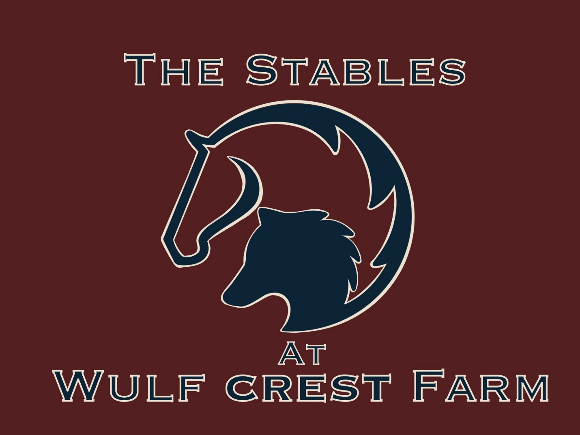

19876 Rider’s Success Ln Leesburg, VA 20175
wcfstables.com

The Stables at Wulf Crest Farm

OFFICIALS
Judge – February 28: Katie Petronelli
Judge – March 28: Kristin Campbell
Competition Manager: Lauren Scarry
Show Secretary: Lauren Scarry
Course Designer: Bruce Leland
Gate: Emma Bakhshi
Official Photographer: TBD

ENTRIES
Online entries accepted via www.striderpro.com
Questions: shows@wcfstables.com | 757-754-1998
- Entries close 7:00 PM Friday prior to the show
- Late entries accepted with $15 late fee, space permitting
- Entries are limited and may close early

FEES & RULES
- Office Fee: $15 per rider
- Class Fee: $35 per class
- Late Entry Fee: $15
All VHSA and TIP classes will be conducted in accordance with the current VHSA and/or TIP Rule Book. The Judge’s decision is final.
Negative Coggins within one year required for all horses, electronic or paper copy.
Six ribbons awarded per class.
Year-end Champion High Point Awards awarded per division.

PARKING & FOOD
Trailer parking is located behind the barn. Car parking is in front of the facility. Please follow posted signage and staff instructions.
Food vendor on site — come hungry!

Rules & Regulations
Class Specifications
All classes designated VHSA or TIP will be conducted and judged in accordance with the current VHSA Rule Book and/or TIP Rule Book. The Judge’s decision is final.
Entries
Entries close at 7:00 PM on the Friday prior to each show date. Late entries will be accepted with a $15 late fee if space permits. Management reserves the right to limit entries, and entries may close early. No office fee refunds will be issued for scratches after the entry closing date. Adds and scratches may be accepted at the gate; please confirm with the show office.
Coggins Test
A negative Coggins test dated within one year is required for all horses. Electronic copies may be emailed to shows@wcfstables.com or uploaded via Strider. Hard copies will also be accepted.
Entry Fees
$35.00 per class
Late Entry Fee
$15.00
Schooling
Schooling will be permitted in the show ring from 7:30 AM – 8:30 AM. Additional schooling breaks may be offered at management’s discretion, time permitting.
Responsibilities
Wulf Crest Farm, horse show staff, and volunteers are not responsible for any accident, injury, loss, or damage to any exhibitor, spectator, rider, groom, guest, animal, or equipment. Management reserves the right to decline or accept any entry; return entry fees before or during the show without liability; and to combine, split, cancel, limit classes, or change officials as necessary.
Dogs
All dogs must be leashed while on the show grounds.
Awards
Six ribbons will be awarded per class. Points will be awarded as follows:
• 3–5 exhibitors: 10, 6, 4, 2, 1, 0.5
• 6–9 exhibitors: 11, 7, 5, 3, 2, 1.5
• 10 or more exhibitors: 12, 8, 6, 4, 3, 2.5
Year-end awards will be presented to the High Point rider in each division.

Division Specifications
Leadline: Open to horses and ponies.
Pre-short Stirrup: Open to riders 10 & under. Riders may be asked to walk, trot, & perform simple Equitation tasks. No cross entry into any canter or jumping classes.
Short Stirrup: Open to riders 12 & under. Fences at 18”. Rider not allowed to cross-enter classes where they jump higher than 18”. Courses may be trotted. VHSA rated.
Long Stirrup: Open to riders 13 & over. Fences at 18”. Horses & Riders may only cross enter into Pleasure, Equitation on the Flat & non VHSA-associated classes.
Mini Hunter: Open. No restrictions on riders. Adults may ride ponies. Fences at 2’.
Low Hunter: Open. No restrictions on riders. Adults may ride ponies. Fences at 2’3.
Schooling Hunter: Open. No restrictions on riders. Adults may ride ponies not entered in a Pony Division. Fences 2’6”.
Thoroughbred Hunter: Open to thoroughbreds who are registered with, or are eligible to be registered with, the Jockey Club. Fences 2’6”. May be combined with Green Hunter (if not combined with S/M/L Green Pony) and/or Working Hunter in order to fill. VHSA/TIP rated.
Green Hunter: Open to horses in their 1st or 2nd year of showing over fences 2’6” and higher. May be combined with Thoroughbred Hunter and/or Working Hunter in order to fill. Fences 2’6”. VHSA rated.
Low Working Hunter: Open to horses and ponies not entered in a pony division. Fences at 2’9”.
Working Hunter: Open to horses and ponies not entered in a pony division. Fences at 3’. VHSA rated.
JR/Adult Hunter Pleasure: Open to all horses in hunter tack ridden by juniors and adults. VHSA rated.
JR/Adult Equitation: Open to Adult Amateurs on horses or Juniors on horses or ponies. Fences at 2’6”. VHSA rated.
Pony Hunter Pleasure: Open to ponies 14.2 hands & under ridden by Junior riders only. VHSA rated.
Pony Equitation: Open to Junior riders on ponies 14.2 hands & under to be shown over fences Sm 2’/Med 2’3”/ Large 2’6”. VHSA rated
Pony Hunter: Open to ponies 14.2 hands & under ridden by Junior riders only. Fences Small 2’/Medium 2’3”/Large 2’6”. May combine Small/Medium & Large if entries warrant. VHSA rated.
Green Pony Hunter: Open to ponies 14.2 hands & under in their 1st or 2nd year of showing over fences. Ridden by Juniors only. Fences Small 2’/Medium 2’3”/Large 2’6”. May combine Small/Medium & Large if entries warrant. VHSA rated.
Child/Adult Medal: Open to Junior or Adult members of VHSA. Riders may not compete in any class where the fence height exceeds 3 feet, 3 inches (1.0m). Rider must be a member of VHSA prior to entry in the class according to Article II, 3. Open to horses only. To be judged separately. VHSA rated.
Child/Adult Hunter: Open to Adult Amateurs on horses or Juniors on horses. Fences at 2’6”. VHSA rated.
California Warm-Up: An unjudged warm-up class to be used one time, per horse/rider combination, before your hunter division of choice

CLASS SCHEDULE
Schooling: 7:30 AM – 8:30 AM
Show Start: 9:00 AM
Warmup
- California Warm-Up

Leadline
- Leadline
Pre-Short Stirrup
- Pre-Short Stirrup – Walk
- Pre-Short Stirrup – Walk/Trot
- Pre-Short Stirrup – Walk/Trot/Test

Short Stirrup – VHSA Associate
- Short Stirrup – Walk/Trot
- Short Stirrup – Walk/Trot/Canter
- Short Stirrup – Over Fences

Long Stirrup
- Long Stirrup – Over Fences
- Long Stirrup – Over Fences
- Long Stirrup – Under Saddle

Jr/Adult Hunter Pleasure – VHSA Associate
- W/T
- W/T/C
- W/T/GAYP

Pony Hunter Pleasure – VHSA Associate
- W/T
- W/T/C
- W/T/GAYP

Mini Hunter (2’)
- Over Fences
- Over Fences
- Under Saddle

Low Hunter (2’3”)
- Over Fences
- Over Fences
- Under Saddle

Schooling Hunter (2’6”)
- Over Fences
- Over Fences
- Under Saddle

Thoroughbred Hunter – VHSA/TIP
- Over Fences
- Over Fences
- Under Saddle

Green Hunter – VHSA Associate
- Over Fences
- Over Fences
- Under Saddle

Low Working Hunter (2’9”)
- Over Fences
- Over Fences
- Under Saddle

Working Hunter – VHSA Associate (3’)
- Over Fences
- Over Fences
- Under Saddle
Children/Adult Medal – VHSA Associate (3’)
- Children/Adult Medal

Pony Hunter – VHSA Associate
- Over Fences
- Over Fences
- Under Saddle

Green Pony Hunter – VHSA Associate
- Over Fences
- Over Fences
- Under Saddle
Pony Equitation – VHSA Associate
- Pony Equitation

Jr/Adult Equitation – VHSA Associate
- Junior/Adult Equitation

Children’s Hunter – VHSA Associate
- Over Fences
- Over Fences
- Under Saddle

Adult Amateur Hunter – VHSA Associate
- Over Fences
- Over Fences
- Under Saddle
THANK YOU TO OUR WONDERFUL SPONSORS!




